Supplementary Material to:
New records of fossil deep-sea shark teeth from the Lillebælt Clay (Early–Middle Eocene) of Denmark.
Bulletin of the Geological Society of Denmark Vol. 72, pp.153–173, 2023.
https://doi.org/10.37570/bgsd-2023-72-06

Jürgen Pollerspöck^{1*}, Kent Albin Nielsen², Iris Feichtinger^{3,4} & Nicolas Straube⁵
¹Bavarian State Collection of Zoology, Münchhausenstraße 21, D-81247 Munich, Germany.
²Tingskoven 22, DK-7330 Brande, Denmark.
³University of Graz, NAWI Geocenter, Institute of Earth Sciences, Heinrichstraße 26, A-8010 Graz, Austria.
⁴Natural History Museum Vienna, Geological-Palaeontological Department, Burgring 7, A-1010 Vienna, Austria.
⁵University Museum Bergen, University of Bergen, N-5007 Bergen, Norway.
*Corresponding author: juergen.pollerspoeck@gmail.com

Table of contents
Part 1: Matrix for absence, presence cluster analysis 2
Part 2: Dendogram, cluster analysis, map of the geographic locations 9
Reference list cluster analysis 19

Part 1: Matrix for absence, presence cluster analysis
The matrix contains all occurring taxa. The cluster analysis was carried out once with all taxa, once with only typical deep-sea taxa (printed in red).
Order | Family | Genus | Central Tethys, France (Ypresian/Lutetian) (1) | Central Tethys, France (Middle Lutetian) (1) | Central Tethys, France (Bartonian) (1) | NSB, Denmark (2, this study) | Central Tethys, Austria (3) | Mediterranean Tethys, Italy, Pesciara (4) | Mediterranean Tethys, Italy, Monte Postale (4) | NSB, United Kingdom (5) | NSB, Germany (6) | Mediterranean Tethys, North Morocco (7) | Mediterranean Tethys, SW Morocco (8) | Mediterranean Tethys, Egypt (9) | Eastern Tethys, India (10) | Eastern Tethys, India (11) | North Atlantic, Senegal (12) | Southern Ocean, Antarctic Peninsula (13) | Mediterranean Tethys, Jordan (14) | Eastern Tethys, Caucasus (Russia), Ukraine (15) | Eastern Tethys, Uzbekistan (16) | Eastern Tethys, Uzbekistan (17) | NSB, Belgium (18) | NSB, Belgium (19) | North Atlantic, Alabama (20) | North Atlantic, Alabama (21) | North Atlantic, Georgia (22) | Caribbean, Mexico (13) | North Atlantic, South Carolina (24) | North Atlantic, South Carolina (25) | North Atlantic, Virginia (26) | South Pacific, Chile (27)
Carcharhiniformes | Carcharhinidae | Abdounia | 1 | 0 | 1 | 0 | 0 | 0 | 0 | 1 | 0 | 1 | 1 | 1 | 1 | 0 | 0 | 0 | 0 | 1 | 1 | 1 | 1 | 1 | 1 | 1 | 1 | 0 | 1 | 1 | 1 | 1
Carcharhiniformes | Carcharhinidae | Carcharhinus | 0 | 0 | 0 | 0 | 0 | 0 | 0 | 0 | 0 | 0 | 1 | 1 | 0 | 0 | 0 | 0 | 0 | 0 | 0 | 0 | 0 | 0 | 0 | 0 | 0 | 0 | 0 | 0 | 0 | 0
Carcharhiniformes | Carcharhinidae | Eogaleus | 0 | 0 | 0 | 0 | 0 | 1 | 1 | 0 | 0 | 0 | 0 | 0 | 0 | 0 | 0 | 0 | 0 | 0 | 0 | 0 | 0 | 0 | 0 | 0 | 0 | 0 | 0 | 0 | 0 | 0
Carcharhiniformes | Carcharhinidae | Isogomphodon | 0 | 0 | 0 | 0 | 0 | 0 | 0 | 0 | 0 | 0 | 0 | 0 | 0 | 0 | 0 | 0 | 0 | 0 | 0 | 0 | 0 | 0 | 0 | 0 | 0 | 0 | 1 | 0 | 0 | 0
Carcharhiniformes | Carcharhinidae | Misrichthys | 0 | 0 | 0 | 0 | 0 | 0 | 0 | 0 | 0 | 0 | 1 | 1 | 0 | 0 | 0 | 0 | 0 | 0 | 0 | 0 | 0 | 0 | 0 | 0 | 0 | 0 | 0 | 0 | 0 | 0
Carcharhiniformes | Carcharhinidae | Negaprion | 0 | 0 | 0 | 0 | 0 | 0 | 0 | 0 | 0 | 0 | 0 | 0 | 0 | 0 | 0 | 0 | 0 | 0 | 0 | 0 | 0 | 0 | 0 | 0 | 1 | 0 | 1 | 0 | 0 | 0
Carcharhiniformes | Carcharhinidae | Physogaleus | 1 | 0 | 0 | 1 | 1 | 0 | 0 | 1 | 0 | 1 | 1 | 1 | 1 | 1 | 1 | 0 | 1 | 1 | 1 | 1 | 1 | 1 | 1 | 1 | 0 | 0 | 1 | 1 | 1 | 0
Carcharhiniformes | Carcharhinidae | Pseudabdounia | 0 | 0 | 0 | 0 | 0 | 0 | 0 | 0 | 0 | 0 | 0 | 0 | 0 | 0 | 0 | 0 | 0 | 0 | 0 | 1 | 1 | 1 | 1 | 1 | 0 | 0 | 0 | 0 | 1 | 0
Carcharhiniformes | Carcharhinidae | Rhizoprionodon | 0 | 0 | 0 | 0 | 0 | 0 | 0 | 0 | 0 | 0 | 1 | 1 | 1 | 0 | 1 | 0 | 1 | 0 | 0 | 1 | 0 | 1 | 1 | 0 | 0 | 0 | 1 | 0 | 0 | 0
Carcharhiniformes | Carcharhinidae | Scoliodon | 0 | 0 | 0 | 0 | 0 | 0 | 0 | 0 | 0 | 0 | 0 | 0 | 0 | 0 | 0 | 1 | 0 | 0 | 0 | 0 | 0 | 0 | 0 | 1 | 0 | 0 | 0 | 0 | 0 | 0
Carcharhiniformes | Galeocerdonidae | Galeocerdo | 0 | 0 | 0 | 0 | 0 | 0 | 0 | 0 | 1 | 0 | 1 | 1 | 1 | 1 | 0 | 0 | 0 | 0 | 0 | 1 | 1 | 0 | 1 | 1 | 1 | 1 | 1 | 0 | 0 | 0
Carcharhiniformes | Hemigaleidae | Hemipristis | 0 | 0 | 0 | 0 | 0 | 0 | 0 | 0 | 0 | 0 | 1 | 1 | 0 | 0 | 0 | 0 | 0 | 0 | 0 | 0 | 0 | 0 | 0 | 0 | 1 | 1 | 1 | 0 | 0 | 0
Carcharhiniformes | Hemigaleidae | Paragaleus | 0 | 0 | 0 | 0 | 0 | 0 | 0 | 0 | 0 | 0 | 1 | 0 | 0 | 0 | 0 | 0 | 0 | 0 | 0 | 0 | 0 | 0 | 0 | 0 | 0 | 0 | 0 | 0 | 0 | 0
Carcharhiniformes | Leptochariidae | Leptocharias | 0 | 0 | 0 | 0 | 0 | 0 | 0 | 0 | 0 | 0 | 0 | 1 | 0 | 0 | 0 | 0 | 0 | 0 | 0 | 0 | 0 | 0 | 0 | 0 | 0 | 0 | 0 | 0 | 0 | 0
Carcharhiniformes | Pentanchidae | Apristurus | 1 | 1 | 0 | 1 | 0 | 0 | 0 | 0 | 0 | 0 | 0 | 0 | 0 | 0 | 0 | 0 | 0 | 0 | 0 | 0 | 0 | 0 | 0 | 0 | 0 | 0 | 0 | 0 | 0 | 0
Carcharhiniformes | Scyliorhinidae | Casieria | 1 | 0 | 0 | 0 | 1 | 0 | 0 | 1 | 0 | 0 | 0 | 0 | 0 | 0 | 0 | 0 | 0 | 0 | 0 | 0 | 0 | 0 | 0 | 0 | 0 | 0 | 0 | 0 | 0 | 0
Carcharhiniformes | Scyliorhinidae | Crassescyliorhinus | 0 | 0 | 0 | 0 | 0 | 0 | 0 | 0 | 0 | 0 | 0 | 1 | 0 | 0 | 0 | 0 | 0 | 0 | 0 | 0 | 0 | 0 | 0 | 0 | 0 | 0 | 0 | 0 | 0 | 0
Carcharhiniformes | Scyliorhinidae | Foumtizia | 1 | 0 | 1 | 1 | 0 | 0 | 0 | 1 | 0 | 1 | 0 | 0 | 0 | 0 | 1 | 0 | 0 | 0 | 0 | 0 | 0 | 1 | 0 | 0 | 0 | 0 | 1 | 0 | 0 | 0
Carcharhiniformes | Scyliorhinidae | Megascyliorhinus | 0 | 1 | 0 | 1 | 1 | 0 | 0 | 1 | 0 | 0 | 0 | 0 | 0 | 0 | 0 | 0 | 0 | 0 | 0 | 0 | 0 | 0 | 0 | 0 | 0 | 0 | 0 | 0 | 0 | 0
Carcharhiniformes | Scyliorhinidae | Microscyliorhinus | 0 | 0 | 0 | 0 | 0 | 0 | 0 | 0 | 0 | 0 | 0 | 0 | 0 | 0 | 0 | 0 | 0 | 0 | 0 | 0 | 0 | 1 | 0 | 0 | 0 | 0 | 0 | 0 | 0 | 0
Carcharhiniformes | Scyliorhinidae | Platyrhizoscyllium | 0 | 1 | 0 | 0 | 0 | 0 | 0 | 0 | 0 | 0 | 0 | 0 | 0 | 0 | 0 | 0 | 0 | 0 | 0 | 0 | 0 | 0 | 0 | 0 | 0 | 0 | 0 | 0 | 0 | 0
Carcharhiniformes | Scyliorhinidae | Premontreia | 1 | 0 | 0 | 0 | 0 | 0 | 0 | 1 | 0 | 0 | 0 | 0 | 0 | 0 | 0 | 0 | 0 | 0 | 0 | 1 | 1 | 1 | 0 | 1 | 0 | 0 | 1 | 1 | 1 | 0
Carcharhiniformes | Scyliorhinidae | Scyliorhinus | 1 | 1 | 1 | 0 | 0 | 0 | 0 | 1 | 0 | 0 | 1 | 0 | 0 | 0 | 1 | 0 | 0 | 0 | 0 | 0 | 0 | 0 | 0 | 0 | 0 | 0 | 1 | 0 | 0 | 0
Carcharhiniformes | Scyliorhinidae | Stenoscyllium | 0 | 0 | 0 | 0 | 0 | 0 | 0 | 0 | 0 | 1 | 0 | 0 | 0 | 0 | 0 | 0 | 0 | 0 | 0 | 0 | 0 | 0 | 0 | 0 | 0 | 0 | 0 | 0 | 0 | 0
Carcharhiniformes | Sphyrnidae | Sphyrna | 0 | 0 | 0 | 0 | 0 | 0 | 0 | 0 | 0 | 0 | 1 | 0 | 0 | 1 | 0 | 0 | 0 | 0 | 0 | 0 | 0 | 0 | 0 | 1 | 0 | 0 | 0 | 0 | 0 | 0
Carcharhiniformes | Triakidae | Galeorhinus | 1 | 0 | 0 | 0 | 0 | 1 | 0 | 1 | 0 | 0 | 1 | 0 | 1 | 1 | 0 | 0 | 1 | 0 | 1 | 1 | 1 | 1 | 1 | 1 | 0 | 0 | 0 | 0 | 1 | 1
Carcharhiniformes | Triakidae | Iago | 1 | 0 | 0 | 0 | 1 | 0 | 0 | 0 | 0 | 0 | 0 | 0 | 0 | 0 | 0 | 0 | 0 | 0 | 0 | 0 | 0 | 0 | 0 | 0 | 0 | 0 | 0 | 0 | 0 | 0
Carcharhiniformes | Triakidae | Mustelus | 0 | 1 | 0 | 0 | 0 | 0 | 0 | 0 | 0 | 0 | 0 | 0 | 0 | 0 | 0 | 0 | 0 | 0 | 0 | 0 | 0 | 0 | 0 | 0 | 0 | 0 | 0 | 0 | 0 | 0
Carcharhiniformes | Triakidae | Pachygaleus | 1 | 0 | 0 | 0 | 0 | 0 | 0 | 1 | 1 | 0 | 0 | 0 | 0 | 0 | 0 | 0 | 0 | 0 | 1 | 0 | 1 | 1 | 1 | 1 | 0 | 0 | 0 | 1 | 1 | 0
Carcharhiniformes | Triakidae | Palaeogaleus | 0 | 0 | 0 | 0 | 0 | 0 | 0 | 0 | 0 | 1 | 0 | 0 | 0 | 0 | 0 | 0 | 0 | 0 | 0 | 0 | 0 | 0 | 0 | 0 | 0 | 0 | 0 | 0 | 1 | 0
Carcharhiniformes | Triakidae | Triakis | 1 | 0 | 0 | 0 | 0 | 0 | 0 | 1 | 0 | 0 | 0 | 0 | 1 | 0 | 1 | 0 | 0 | 0 | 0 | 0 | 0 | 0 | 0 | 0 | 0 | 0 | 0 | 0 | 1 | 0
Carcharhiniformes | Triakidae | Xystrogaleus | 0 | 1 | 0 | 0 | 0 | 0 | 0 | 0 | 0 | 0 | 0 | 0 | 0 | 0 | 0 | 0 | 0 | 0 | 0 | 0 | 0 | 0 | 0 | 0 | 0 | 0 | 0 | 0 | 0 | 0
Echinorhiniformes | Echinorhinidae | Echinorhinus | 1 | 0 | 0 | 1 | 1 | 0 | 0 | 0 | 0 | 1 | 0 | 0 | 0 | 0 | 0 | 0 | 0 | 1 | 0 | 0 | 0 | 0 | 0 | 0 | 0 | 0 | 0 | 0 | 1 | 0
Echinorhiniformes | Echinorhinidae | Orthechinorhinus | 1 | 1 | 1 | 1 | 1 | 0 | 0 | 0 | 0 | 0 | 0 | 0 | 0 | 0 | 0 | 0 | 0 | 0 | 0 | 0 | 0 | 0 | 0 | 0 | 0 | 0 | 0 | 0 | 0 | 0
Echinorhiniformes | Echinorhinidae | Paraechinorhinus | 0 | 0 | 0 | 0 | 1 | 0 | 0 | 0 | 0 | 0 | 0 | 0 | 0 | 0 | 0 | 0 | 0 | 0 | 0 | 0 | 0 | 0 | 0 | 0 | 0 | 0 | 0 | 0 | 0 | 0
Heterodontiformes | Heterodontidae | Heterodontus | 1 | 0 | 0 | 0 | 1 | 0 | 0 | 1 | 0 | 0 | 0 | 0 | 0 | 0 | 0 | 0 | 0 | 0 | 0 | 1 | 1 | 1 | 0 | 0 | 1 | 0 | 0 | 1 | 1 | 0
Hexanchiformes | Chlamydoselachidae | Chlamydoselachus | 0 | 1 | 0 | 1 | 1 | 0 | 0 | 0 | 0 | 0 | 0 | 0 | 0 | 0 | 0 | 0 | 0 | 0 | 0 | 0 | 0 | 0 | 0 | 0 | 0 | 0 | 0 | 0 | 0 | 0
Hexanchiformes | Hexanchidae | Heptranchias | 1 | 0 | 0 | 1 | 0 | 0 | 0 | 0 | 0 | 1 | 0 | 0 | 0 | 0 | 0 | 1 | 0 | 0 | 0 | 0 | 0 | 0 | 0 | 0 | 0 | 0 | 0 | 0 | 0 | 0
Hexanchiformes | Hexanchidae | Hexanchus | 1 | 0 | 0 | 1 | 1 | 0 | 0 | 1 | 0 | 1 | 0 | 0 | 0 | 0 | 0 | 1 | 1 | 0 | 0 | 0 | 0 | 0 | 0 | 0 | 0 | 0 | 0 | 0 | 1 | 1
Hexanchiformes | Hexanchidae | Notorynchus | 0 | 0 | 0 | 1 | 1 | 0 | 0 | 1 | 0 | 1 | 0 | 0 | 0 | 1 | 0 | 0 | 0 | 0 | 0 | 1 | 1 | 0 | 0 | 0 | 0 | 0 | 1 | 0 | 0 | 0
Hexanchiformes | Hexanchidae | Weltonia | 0 | 0 | 0 | 1 | 0 | 0 | 0 | 1 | 0 | 1 | 0 | 0 | 0 | 0 | 0 | 0 | 0 | 0 | 0 | 0 | 0 | 0 | 0 | 0 | 0 | 0 | 0 | 0 | 0 | 0
incert. sedis | incert. fam. | Odontorhytis | 0 | 0 | 0 | 0 | 0 | 0 | 0 | 0 | 0 | 0 | 1 | 1 | 0 | 0 | 1 | 0 | 0 | 0 | 0 | 0 | 0 | 0 | 0 | 0 | 0 | 0 | 0 | 0 | 0 | 0
Lamniformes | Alopiidae | Alopias | 1 | 1 | 0 | 1 | 1 | 0 | 0 | 1 | 0 | 1 | 1 | 1 | 0 | 0 | 0 | 0 | 1 | 1 | 1 | 0 | 0 | 0 | 0 | 0 | 0 | 0 | 1 | 0 | 0 | 0
Lamniformes | Alopiidae | Trigonotodus | 0 | 0 | 0 | 0 | 1 | 0 | 0 | 0 | 0 | 0 | 0 | 0 | 0 | 0 | 0 | 0 | 0 | 0 | 1 | 0 | 0 | 0 | 0 | 0 | 0 | 0 | 0 | 0 | 0 | 0
Lamniformes | Alopiidae | Usakias | 0 | 0 | 0 | 1 | 1 | 0 | 0 | 0 | 1 | 0 | 0 | 0 | 0 | 0 | 0 | 0 | 0 | 0 | 1 | 0 | 1 | 0 | 0 | 0 | 0 | 0 | 0 | 0 | 0 | 0
Lamniformes | Carchariidae | Carcharias | 1 | 0 | 0 | 1 | 1 | 0 | 0 | 0 | 1 | 1 | 1 | 0 | 0 | 0 | 0 | 0 | 0 | 0 | 0 | 0 | 1 | 0 | 0 | 0 | 0 | 1 | 1 | 0 | 0 | 0
Lamniformes | Lamnidae | Cosmopolitodus | 0 | 0 | 0 | 0 | 0 | 0 | 0 | 0 | 0 | 0 | 0 | 0 | 0 | 0 | 0 | 0 | 1 | 0 | 0 | 0 | 0 | 0 | 0 | 0 | 0 | 0 | 0 | 0 | 0 | 0
Lamniformes | Lamnidae | Isurolamna | 1 | 1 | 0 | 1 | 1 | 0 | 0 | 1 | 1 | 1 | 0 | 0 | 0 | 0 | 0 | 0 | 0 | 1 | 1 | 0 | 1 | 1 | 0 | 1 | 0 | 0 | 0 | 0 | 0 | 0
Lamniformes | Lamnidae | Isurus | 1 | 1 | 0 | 0 | 0 | 0 | 0 | 0 | 1 | 0 | 0 | 0 | 0 | 0 | 0 | 0 | 0 | 0 | 0 | 0 | 0 | 0 | 0 | 0 | 1 | 0 | 0 | 0 | 0 | 0
Lamniformes | Lamnidae | Karaisurus | 0 | 0 | 0 | 0 | 0 | 0 | 0 | 0 | 0 | 0 | 0 | 0 | 0 | 0 | 0 | 0 | 0 | 0 | 1 | 0 | 0 | 0 | 0 | 0 | 0 | 0 | 0 | 0 | 0 | 0
Lamniformes | Lamnidae | Lamna | 0 | 0 | 0 | 0 | 0 | 0 | 0 | 0 | 0 | 0 | 0 | 0 | 0 | 0 | 0 | 0 | 1 | 0 | 0 | 0 | 0 | 0 | 0 | 0 | 0 | 0 | 0 | 0 | 0 | 0
Lamniformes | Lamnidae | Lethenia | 0 | 0 | 0 | 0 | 1 | 0 | 0 | 0 | 0 | 0 | 0 | 0 | 0 | 0 | 0 | 0 | 0 | 0 | 0 | 0 | 0 | 0 | 0 | 0 | 0 | 0 | 0 | 0 | 0 | 0
Lamniformes | Lamnidae | Macrorhizodus | 0 | 0 | 0 | 1 | 1 | 0 | 0 | 1 | 1 | 0 | 1 | 1 | 0 | 0 | 0 | 0 | 0 | 1 | 1 | 1 | 1 | 0 | 0 | 1 | 1 | 1 | 0 | 0 | 0 | 1
Lamniformes | Mitsukurinidae | Anomotodon | 1 | 0 | 0 | 1 | 0 | 0 | 0 | 1 | 1 | 0 | 0 | 0 | 0 | 0 | 0 | 1 | 0 | 0 | 0 | 0 | 1 | 0 | 0 | 0 | 0 | 0 | 0 | 1 | 1 | 1
Lamniformes | Mitsukurinidae | Mitsukurina | 1 | 1 | 0 | 0 | 1 | 0 | 0 | 0 | 0 | 0 | 0 | 0 | 0 | 0 | 0 | 0 | 0 | 0 | 0 | 0 | 0 | 0 | 0 | 0 | 0 | 0 | 0 | 0 | 0 | 0
Lamniformes | Mitsukurinidae | Striatolamia | 1 | 1 | 0 | 1 | 1 | 0 | 0 | 1 | 1 | 1 | 0 | 0 | 0 | 0 | 0 | 1 | 0 | 1 | 1 | 0 | 1 | 1 | 1 | 1 | 0 | 1 | 0 | 1 | 1 | 1
Lamniformes | Mitsukurinidae | Woellsteinia | 1 | 0 | 0 | 1 | 1 | 0 | 0 | 0 | 0 | 0 | 0 | 0 | 0 | 0 | 0 | 0 | 0 | 0 | 0 | 0 | 0 | 0 | 0 | 0 | 0 | 0 | 0 | 0 | 0 | 0
Lamniformes | Odontaspididae | Araloselachus | 0 | 0 | 0 | 0 | 0 | 0 | 0 | 0 | 0 | 0 | 0 | 0 | 0 | 0 | 0 | 0 | 0 | 0 | 0 | 0 | 0 | 0 | 0 | 0 | 1 | 0 | 0 | 0 | 0 | 0
Lamniformes | Odontaspididae | Brachycarcharias | 0 | 0 | 0 | 0 | 1 | 1 | 1 | 1 | 1 | 1 | 1 | 1 | 0 | 0 | 1 | 0 | 0 | 0 | 1 | 0 | 1 | 1 | 1 | 1 | 1 | 0 | 0 | 1 | 1 | 0
Lamniformes | Odontaspididae | Carcharoides | 0 | 0 | 0 | 0 | 0 | 0 | 0 | 0 | 0 | 0 | 0 | 0 | 0 | 0 | 0 | 0 | 0 | 0 | 0 | 0 | 0 | 0 | 0 | 0 | 0 | 0 | 0 | 0 | 0 | 1
Lamniformes | Odontaspididae | Hypotodus | 1 | 0 | 0 | 1 | 0 | 0 | 0 | 1 | 1 | 1 | 0 | 0 | 0 | 0 | 0 | 0 | 1 | 0 | 1 | 1 | 1 | 1 | 1 | 1 | 0 | 0 | 0 | 0 | 1 | 1
Lamniformes | Odontaspididae | Jaekelotodus | 0 | 0 | 0 | 1 | 0 | 0 | 0 | 1 | 1 | 0 | 0 | 0 | 0 | 0 | 0 | 0 | 0 | 0 | 1 | 1 | 1 | 1 | 1 | 1 | 0 | 0 | 0 | 0 | 0 | 0
Lamniformes | Odontaspididae | Odontaspis | 1 | 0 | 0 | 1 | 0 | 0 | 0 | 1 | 1 | 1 | 0 | 0 | 0 | 0 | 0 | 0 | 0 | 0 | 1 | 1 | 1 | 1 | 0 | 1 | 0 | 1 | 0 | 0 | 1 | 1
Lamniformes | Odontaspididae | Palaeohypotodus | 0 | 0 | 0 | 1 | 0 | 0 | 0 | 1 | 0 | 0 | 0 | 0 | 0 | 0 | 0 | 1 | 0 | 0 | 0 | 0 | 0 | 1 | 0 | 0 | 0 | 0 | 0 | 0 | 1 | 0
Lamniformes | Odontaspididae | Sylvestrilamia | 0 | 0 | 0 | 0 | 0 | 0 | 0 | 1 | 1 | 0 | 0 | 0 | 0 | 0 | 0 | 0 | 0 | 0 | 0 | 0 | 1 | 1 | 1 | 0 | 0 | 0 | 0 | 0 | 1 | 0
Lamniformes | Odontaspididae | Tethylamna | 0 | 0 | 0 | 0 | 0 | 0 | 0 | 0 | 0 | 0 | 0 | 0 | 0 | 0 | 0 | 0 | 0 | 0 | 0 | 0 | 0 | 0 | 0 | 1 | 0 | 0 | 0 | 0 | 0 | 0
Lamniformes | Odontaspididae | Turania | 0 | 0 | 0 | 1 | 0 | 0 | 0 | 0 | 0 | 0 | 0 | 0 | 0 | 0 | 0 | 0 | 0 | 0 | 0 | 0 | 0 | 0 | 0 | 0 | 0 | 0 | 0 | 0 | 0 | 0
Lamniformes | Otodontidae | Cretalamna | 1 | 0 | 0 | 1 | 0 | 0 | 0 | 1 | 0 | 1 | 0 | 0 | 0 | 0 | 0 | 0 | 0 | 0 | 0 | 1 | 0 | 0 | 0 | 1 | 0 | 0 | 0 | 0 | 1 | 0
Lamniformes | Otodontidae | Otodus | 1 | 0 | 0 | 1 | 1 | 0 | 0 | 1 | 1 | 1 | 1 | 1 | 0 | 0 | 0 | 1 | 1 | 1 | 1 | 1 | 1 | 1 | 1 | 1 | 1 | 1 | 0 | 0 | 1 | 1
Lamniformes | Otodontidae | Parotodus | 0 | 0 | 0 | 0 | 0 | 0 | 0 | 1 | 0 | 0 | 0 | 0 | 0 | 0 | 0 | 0 | 0 | 0 | 0 | 0 | 0 | 1 | 0 | 0 | 0 | 0 | 0 | 0 | 0 | 0
Lamniformes | Serratolamnidae | Serratolamna | 0 | 0 | 0 | 0 | 0 | 0 | 0 | 0 | 0 | 0 | 0 | 0 | 0 | 0 | 1 | 0 | 1 | 0 | 0 | 0 | 0 | 0 | 0 | 0 | 0 | 0 | 0 | 0 | 1 | 0
Lamniformes | Xiphodolamiidae | Xiphodolamia | 0 | 0 | 0 | 1 | 1 | 0 | 0 | 1 | 1 | 0 | 1 | 0 | 0 | 0 | 0 | 0 | 1 | 0 | 1 | 0 | 1 | 0 | 0 | 0 | 0 | 0 | 0 | 0 | 0 | 0
Orectolobiformes | Brachaeluridae | Eostegostoma | 1 | 1 | 0 | 0 | 1 | 0 | 0 | 0 | 0 | 0 | 0 | 1 | 0 | 0 | 0 | 0 | 0 | 0 | 1 | 0 | 1 | 0 | 0 | 0 | 0 | 0 | 0 | 0 | 0 | 0
Orectolobiformes | Ginglymostomatidae | Delpitoscyllium | 0 | 0 | 0 | 0 | 0 | 0 | 0 | 0 | 0 | 0 | 0 | 0 | 0 | 0 | 0 | 0 | 0 | 0 | 0 | 0 | 0 | 0 | 0 | 0 | 0 | 0 | 0 | 0 | 1 | 0
Orectolobiformes | Ginglymostomatidae | Ginglymostoma | 0 | 0 | 0 | 0 | 0 | 0 | 0 | 0 | 0 | 1 | 0 | 0 | 0 | 0 | 1 | 0 | 0 | 0 | 0 | 0 | 0 | 0 | 0 | 0 | 0 | 0 | 0 | 0 | 1 | 0
Orectolobiformes | Ginglymostomatidae | Nebrius | 0 | 0 | 0 | 0 | 0 | 0 | 0 | 0 | 0 | 0 | 1 | 1 | 0 | 0 | 1 | 0 | 0 | 0 | 0 | 0 | 1 | 1 | 1 | 1 | 1 | 1 | 1 | 1 | 1 | 0
Orectolobiformes | Ginglymostomatidae | Protoginglymostoma | 0 | 0 | 0 | 0 | 0 | 0 | 0 | 0 | 0 | 0 | 0 | 0 | 0 | 0 | 1 | 0 | 0 | 0 | 0 | 0 | 1 | 0 | 0 | 0 | 0 | 0 | 0 | 1 | 0 | 0
Orectolobiformes | Ginglymostomatidae | Pseudoginglymostoma | 0 | 0 | 0 | 0 | 0 | 0 | 0 | 0 | 0 | 0 | 0 | 0 | 0 | 0 | 0 | 1 | 0 | 0 | 0 | 0 | 0 | 0 | 0 | 0 | 0 | 0 | 0 | 0 | 0 | 0
Orectolobiformes | Hemiscylliidae | Chiloscyllium | 0 | 0 | 0 | 0 | 0 | 0 | 0 | 0 | 0 | 0 | 1 | 0 | 0 | 0 | 1 | 0 | 0 | 0 | 0 | 0 | 0 | 0 | 0 | 0 | 0 | 0 | 0 | 0 | 0 | 0
Orectolobiformes | Hemiscylliidae | Hemiscyllium | 1 | 0 | 1 | 0 | 0 | 0 | 0 | 0 | 0 | 0 | 0 | 1 | 0 | 0 | 0 | 0 | 0 | 0 | 0 | 0 | 0 | 0 | 0 | 0 | 0 | 0 | 0 | 1 | 0 | 0
Orectolobiformes | Hemiscylliidae | Notoramphoscyllium | 0 | 0 | 0 | 0 | 0 | 0 | 0 | 0 | 0 | 0 | 0 | 0 | 0 | 0 | 0 | 1 | 0 | 0 | 0 | 0 | 0 | 0 | 0 | 0 | 0 | 0 | 0 | 0 | 0 | 0
Orectolobiformes | Orectolobidae | Coelometlaouia | 0 | 0 | 0 | 0 | 0 | 0 | 0 | 0 | 0 | 0 | 0 | 0 | 0 | 0 | 0 | 1 | 0 | 0 | 0 | 0 | 0 | 0 | 0 | 0 | 0 | 0 | 0 | 0 | 0 | 0
Orectolobiformes | Orectolobidae | Eometlaouia | 0 | 0 | 0 | 0 | 0 | 0 | 0 | 0 | 0 | 0 | 0 | 0 | 0 | 0 | 0 | 0 | 0 | 0 | 0 | 0 | 0 | 0 | 1 | 0 | 0 | 0 | 0 | 0 | 0 | 0
Orectolobiformes | Orectolobidae | Orectoloboides | 0 | 1 | 1 | 0 | 0 | 0 | 0 | 0 | 0 | 0 | 0 | 0 | 0 | 0 | 0 | 0 | 0 | 0 | 0 | 0 | 0 | 0 | 0 | 0 | 0 | 0 | 0 | 0 | 0 | 0
Orectolobiformes | Orectolobidae | Orectolobus | 0 | 0 | 0 | 0 | 0 | 0 | 0 | 0 | 0 | 0 | 0 | 0 | 0 | 0 | 0 | 0 | 0 | 0 | 0 | 0 | 0 | 0 | 1 | 1 | 0 | 0 | 0 | 0 | 0 | 0
Orectolobiformes | Orectolobidae | Squatiscyllium | 0 | 0 | 0 | 0 | 0 | 0 | 0 | 0 | 0 | 0 | 0 | 0 | 0 | 0 | 1 | 0 | 0 | 0 | 0 | 0 | 0 | 0 | 0 | 0 | 0 | 0 | 0 | 0 | 0 | 0
Orectolobiformes | Parascylliidae | Pararhincodon | 1 | 1 | 1 | 0 | 0 | 0 | 0 | 0 | 0 | 0 | 0 | 1 | 0 | 0 | 0 | 0 | 0 | 0 | 0 | 0 | 0 | 1 | 0 | 0 | 0 | 0 | 0 | 0 | 0 | 0
Orectolobiformes | Parascylliidae | Parascyllium | 0 | 1 | 0 | 0 | 0 | 0 | 0 | 0 | 0 | 0 | 0 | 0 | 0 | 0 | 0 | 0 | 0 | 0 | 0 | 0 | 0 | 0 | 0 | 0 | 0 | 0 | 0 | 0 | 0 | 0
Orectolobiformes | Rhincodontidae | Palaeorhincodon | 0 | 1 | 0 | 0 | 0 | 0 | 0 | 1 | 0 | 0 | 0 | 0 | 0 | 0 | 0 | 0 | 0 | 0 | 0 | 1 | 1 | 0 | 0 | 0 | 0 | 0 | 0 | 1 | 1 | 0
Pristiophoriformes | Pristiophoridae | Pristiophorus | 0 | 1 | 0 | 1 | 1 | 0 | 0 | 0 | 0 | 0 | 0 | 0 | 0 | 0 | 0 | 1 | 0 | 0 | 0 | 0 | 0 | 0 | 0 | 0 | 0 | 0 | 0 | 0 | 0 | 0
Squaliformes | Centrophoridae | Centrophorus | 0 | 1 | 0 | 1 | 1 | 0 | 0 | 0 | 0 | 0 | 0 | 0 | 0 | 0 | 0 | 1 | 0 | 0 | 0 | 0 | 0 | 0 | 0 | 0 | 0 | 0 | 0 | 0 | 0 | 0
Squaliformes | Centrophoridae | Deania | 0 | 1 | 0 | 1 | 0 | 0 | 0 | 0 | 0 | 0 | 0 | 0 | 0 | 0 | 0 | 1 | 0 | 0 | 0 | 0 | 0 | 0 | 0 | 0 | 0 | 0 | 0 | 0 | 0 | 0
Squaliformes | Dalatiidae | Acrosqualiolus | 0 | 1 | 0 | 0 | 0 | 0 | 0 | 0 | 0 | 0 | 0 | 0 | 0 | 0 | 0 | 0 | 0 | 0 | 0 | 0 | 0 | 0 | 0 | 0 | 0 | 0 | 0 | 0 | 0 | 0
Squaliformes | Dalatiidae | Angoumeius | 0 | 1 | 1 | 0 | 0 | 0 | 0 | 0 | 0 | 0 | 0 | 0 | 0 | 0 | 0 | 0 | 0 | 0 | 0 | 0 | 0 | 0 | 0 | 0 | 0 | 0 | 0 | 0 | 0 | 0
Squaliformes | Dalatiidae | Dalatias | 1 | 1 | 0 | 0 | 0 | 0 | 0 | 0 | 0 | 0 | 0 | 0 | 0 | 0 | 0 | 0 | 0 | 0 | 0 | 0 | 0 | 0 | 0 | 0 | 0 | 0 | 0 | 0 | 0 | 0
Squaliformes | Dalatiidae | Eodalatias | 0 | 0 | 0 | 0 | 0 | 0 | 0 | 0 | 0 | 0 | 0 | 0 | 0 | 0 | 0 | 1 | 0 | 0 | 0 | 0 | 0 | 0 | 0 | 0 | 0 | 0 | 0 | 0 | 0 | 0
Squaliformes | Dalatiidae | Eosqualiolus | 0 | 1 | 0 | 0 | 1 | 0 | 0 | 0 | 0 | 0 | 0 | 0 | 0 | 0 | 0 | 0 | 0 | 0 | 0 | 0 | 0 | 0 | 0 | 0 | 0 | 0 | 0 | 0 | 0 | 0
Squaliformes | Dalatiidae | Euprotomicroides | 0 | 1 | 0 | 0 | 0 | 0 | 0 | 0 | 0 | 0 | 0 | 0 | 0 | 0 | 0 | 0 | 0 | 0 | 0 | 0 | 0 | 0 | 0 | 0 | 0 | 0 | 0 | 0 | 0 | 0
Squaliformes | Dalatiidae | Isistius | 0 | 1 | 0 | 1 | 1 | 0 | 0 | 1 | 0 | 1 | 0 | 0 | 0 | 0 | 0 | 0 | 0 | 0 | 0 | 1 | 1 | 1 | 0 | 0 | 0 | 0 | 0 | 0 | 1 | 0
Squaliformes | Dalatiidae | Oligodalatias | 0 | 0 | 0 | 1 | 0 | 0 | 0 | 0 | 0 | 0 | 0 | 0 | 0 | 0 | 0 | 0 | 0 | 0 | 0 | 0 | 0 | 0 | 0 | 0 | 0 | 0 | 0 | 0 | 0 | 0
Squaliformes | Dalatiidae | Squaliodalatias | 1 | 1 | 1 | 0 | 0 | 0 | 0 | 0 | 0 | 0 | 0 | 0 | 0 | 0 | 0 | 0 | 0 | 0 | 0 | 0 | 0 | 0 | 0 | 0 | 0 | 0 | 0 | 0 | 0 | 0
Squaliformes | Dalatiidae | Squaliolus | 0 | 1 | 1 | 1 | 0 | 0 | 0 | 0 | 0 | 0 | 0 | 0 | 0 | 0 | 0 | 0 | 0 | 0 | 0 | 0 | 0 | 0 | 0 | 0 | 0 | 0 | 0 | 0 | 0 | 0
Squaliformes | Etmopteridae | Etmopterus | 0 | 1 | 0 | 1 | 0 | 0 | 0 | 0 | 0 | 0 | 0 | 0 | 0 | 0 | 0 | 0 | 0 | 0 | 0 | 0 | 0 | 0 | 0 | 0 | 0 | 0 | 0 | 0 | 0 | 0
Squaliformes | Etmopteridae | Paraetmopterus | 1 | 1 | 1 | 1 | 0 | 0 | 0 | 0 | 0 | 0 | 0 | 0 | 0 | 0 | 0 | 0 | 0 | 0 | 0 | 0 | 0 | 0 | 0 | 0 | 0 | 0 | 0 | 0 | 0 | 0
Squaliformes | Somniosidae | Centroscymnus | 0 | 1 | 0 | 0 | 0 | 0 | 0 | 0 | 0 | 0 | 0 | 0 | 0 | 0 | 0 | 0 | 0 | 0 | 0 | 0 | 0 | 0 | 0 | 0 | 0 | 0 | 0 | 0 | 0 | 0
Squaliformes | Somniosidae | Scymnodalatias | 0 | 1 | 0 | 0 | 0 | 0 | 0 | 0 | 0 | 0 | 0 | 0 | 0 | 0 | 0 | 0 | 0 | 0 | 0 | 0 | 0 | 0 | 0 | 0 | 0 | 0 | 0 | 0 | 0 | 0
Squaliformes | Squalidae | Squalus | 0 | 0 | 0 | 0 | 0 | 0 | 0 | 1 | 0 | 0 | 0 | 0 | 0 | 0 | 0 | 1 | 0 | 0 | 0 | 1 | 0 | 1 | 0 | 0 | 0 | 0 | 0 | 0 | 1 | 0
Squatiniformes | Squatinidae | Squatina | 1 | 0 | 0 | 1 | 1 | 0 | 0 | 1 | 0 | 1 | 0 | 0 | 0 | 0 | 0 | 1 | 1 | 0 | 0 | 1 | 1 | 1 | 0 | 0 | 0 | 0 | 1 | 1 | 1 | 1

Part 2: Dendogram, cluster analysis, map of the geographic locations

The following four indices are statistic tools used to gauge the similarity of two or more samples (for binary absence-presence data, coded as 0 or 1) (see Reference manual for PAST PAleontological Statistics, Version 4.12. Øyvind Hammer 2022).

- Dice or Sørensen–Dice coefficient index
When comparing two rows, a match is counted for all columns that are present in both rows.
M=number of matches
N=number of columns
Used Formula: d_{jk} = 2M / (2M+N).
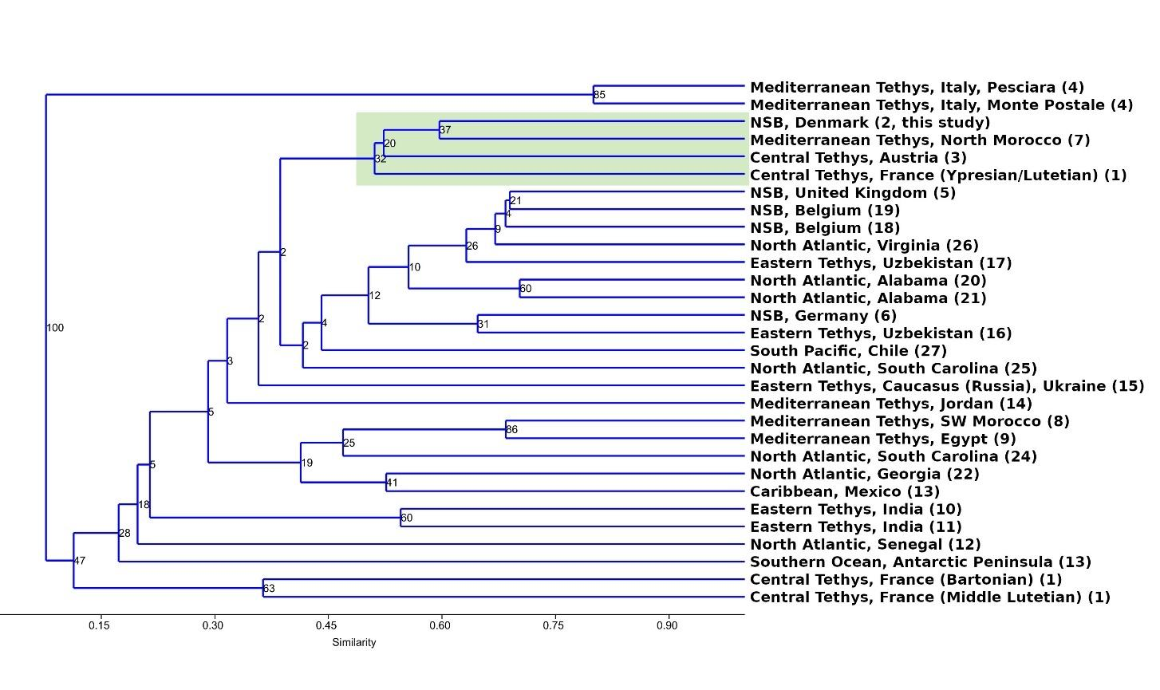
Figure 1: Dice or Sørensen–Dice coefficient, all taxa.

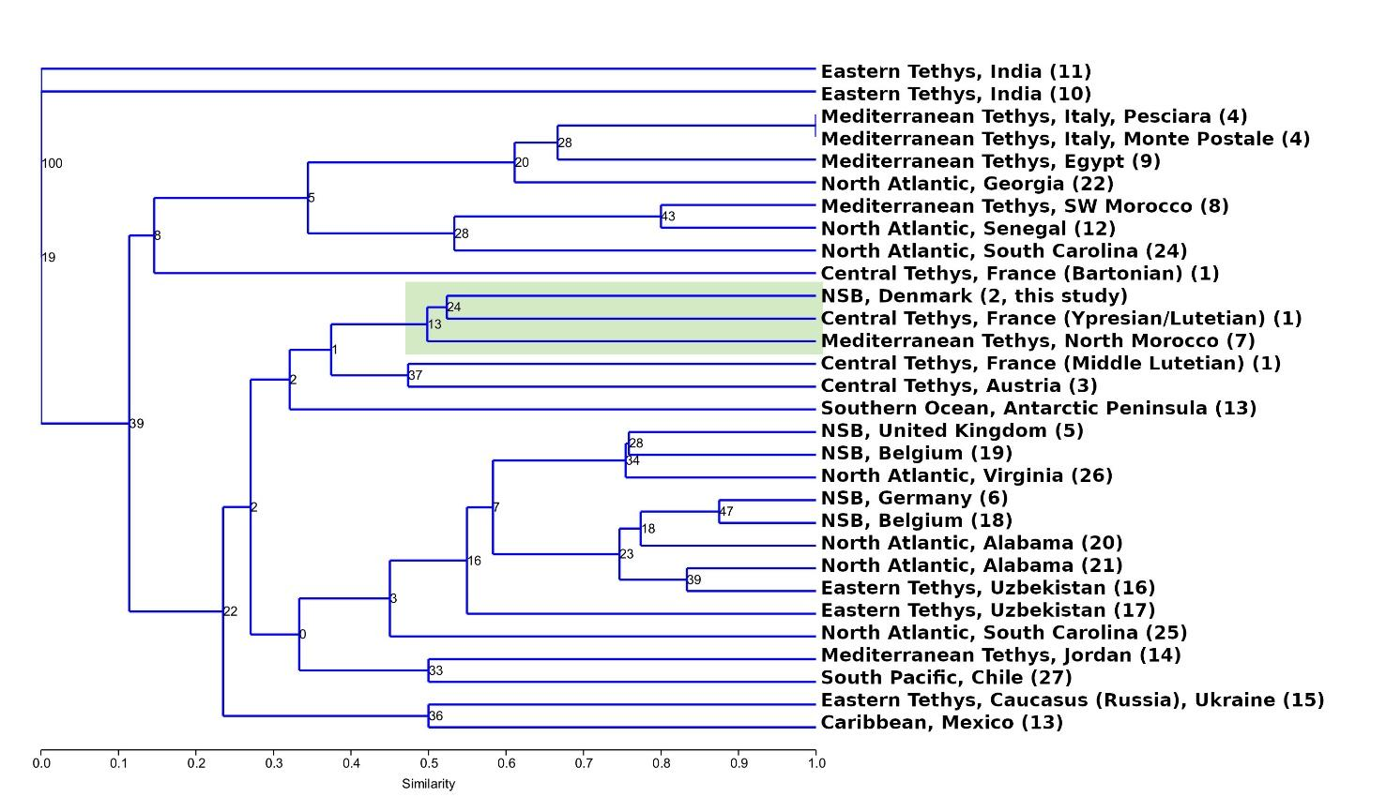
Figure 2: a) Dice or Sørensen–Dice coefficient, only deep-sea taxa.

- Kulczynski Index
When comparing two rows, a match is counted for all columns that are present in both rows. With the same notation as given for Dice similarity above (with N1 and N2 referring to the two rows):
M=number of matches
N =number of columns
Used Formula: d_{jk} = $\frac{\frac{M}{M+N_{1}}+\frac{M}{M+N_{2}}}{2}$
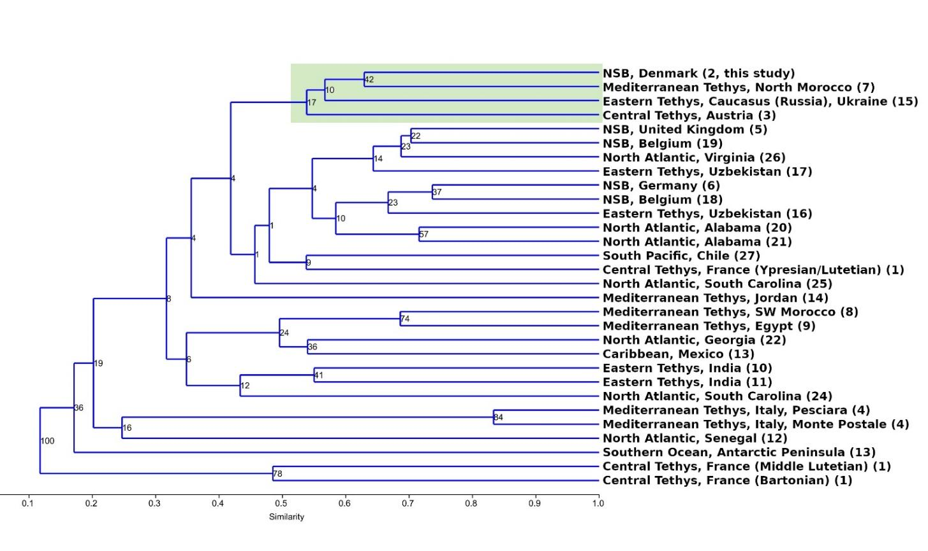
Figure 3: Kulczynski Index, all taxa.
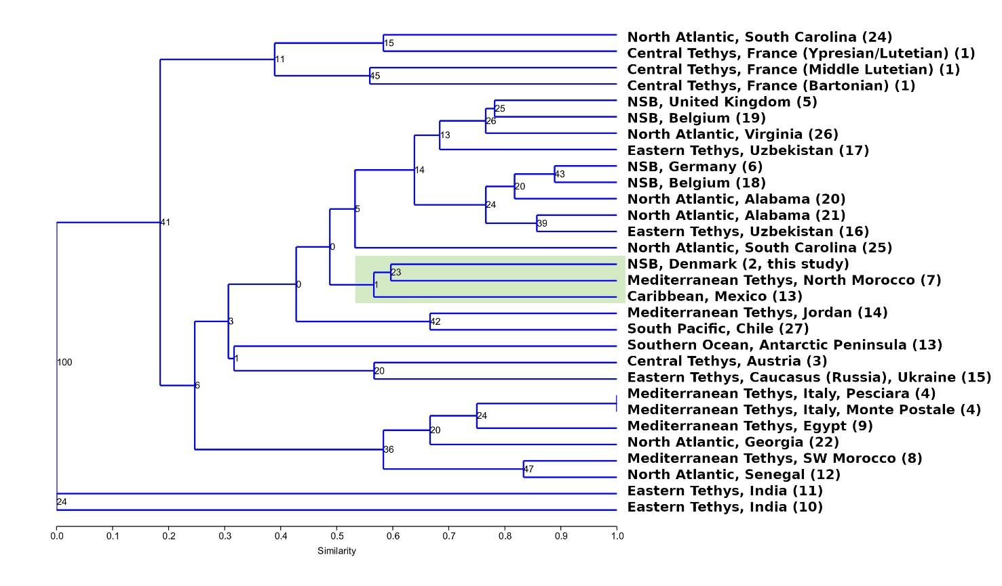
Figure 4: Kulczynski Index, only deep-sea taxa.

- Jaccard Index
When comparing two rows, a match is counted for all columns that are present in both rows.
M=number of matches
N=number of columns
Used Formula: d_{jk} = M / (M+N).
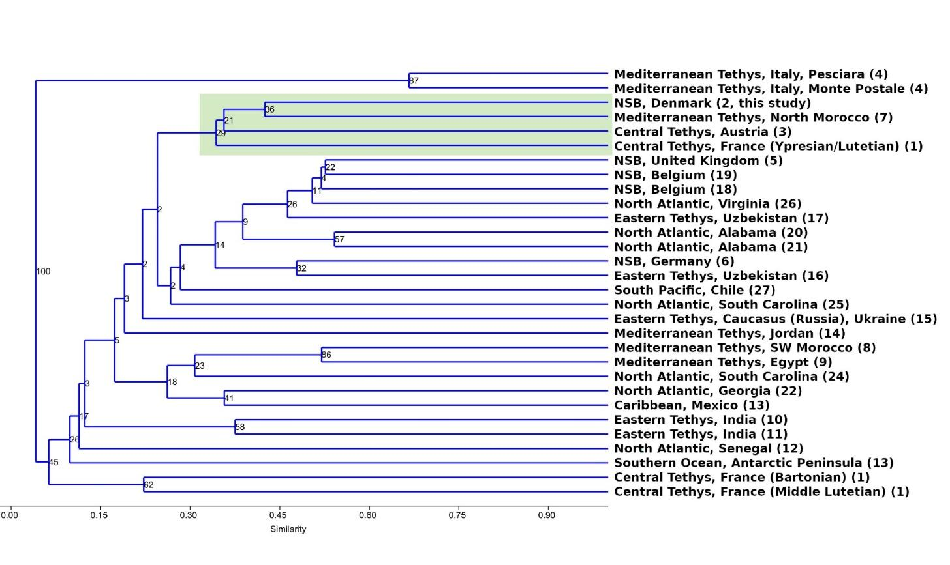
Figure 5: Jaccard Index, all taxa.
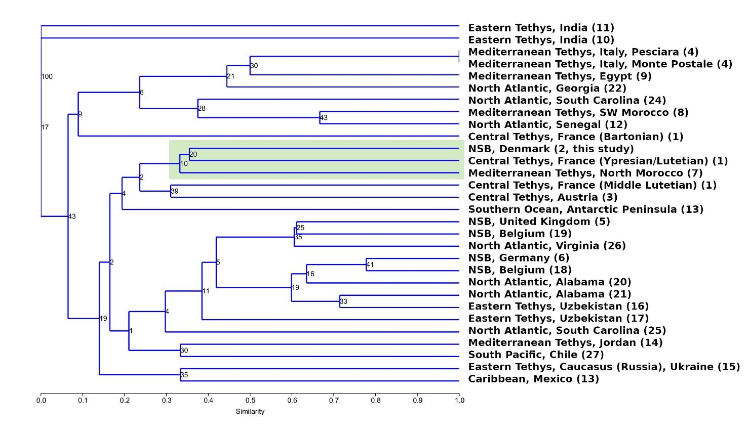
Figure 6: Jaccard Index, only deep-sea taxa.

- Ochiai Index
When comparing two rows, a match is counted for all columns that are present in both rows. With the same notation as given for Dice similarity above (with N1 and N2 referring to the two rows):
M=number of matches
N =number of columns
Used Formula: d_{jk} = $\sqrt{\frac{M}{M+N_{1}}\frac{M}{M+N_{2}}}$
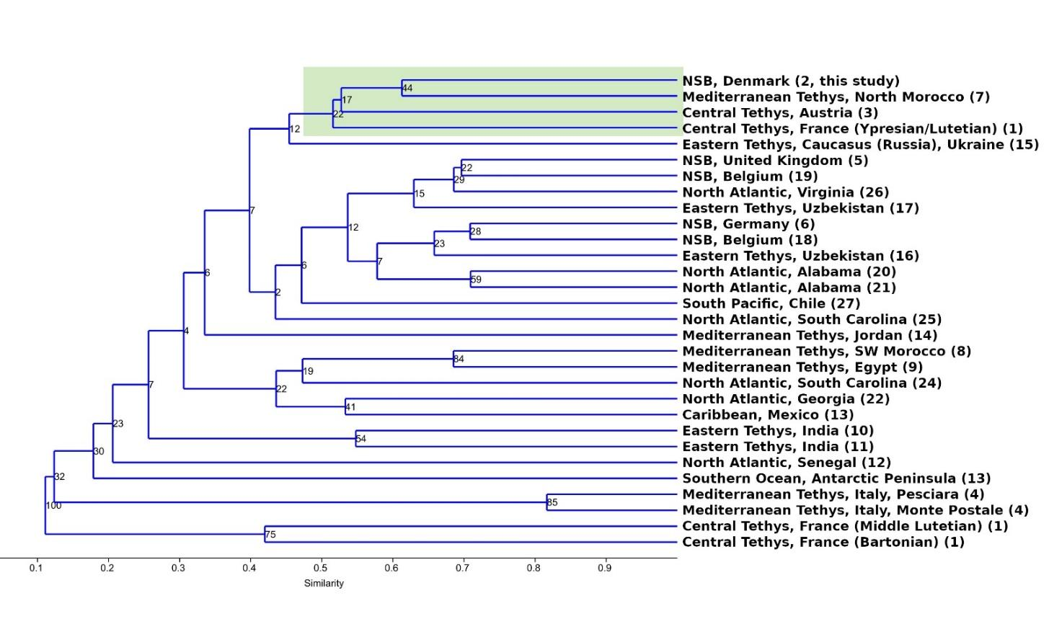
Figure 7: Ochiai Index, all taxa.
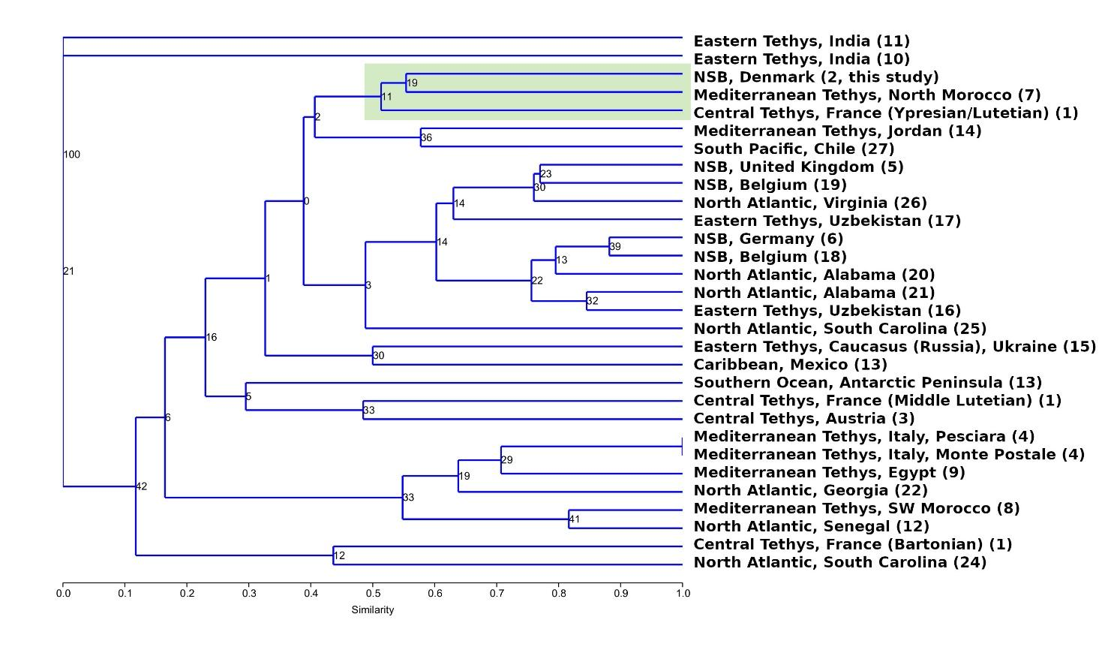
Figure 8: Ochiai Index, only deep-sea taxa.

- Map of the geographic locations
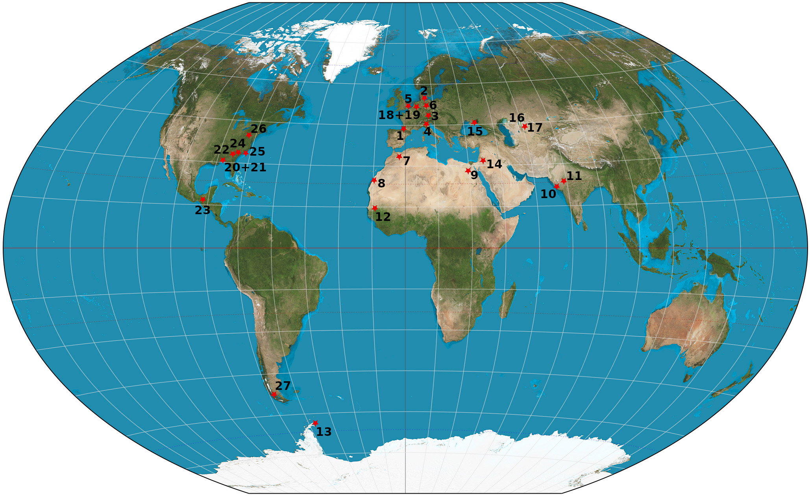
Fig. Suppl- Mat. Map of the geographic locations of the 27 sites used for cluster analysis.

Reference list cluster analysis
(1) Adnet, S. 2006: Nouvelles faunes de sélaciens (Elasmobranchii, Neoselachii) de l'Éocène des Landes (Sud-Ouest, France). Implication dans les connaissances des communautés d'eaux profondes. Palaeo Ichthyologica, 10, 1–128.
(1) Adnet, S., Cappetta, H. & Reynders, J. 2008: Contribution of Eocene sharks and rays from Southern France to the history of deep‐sea selachians. Acta Geologica Polonica 58, 257–260.
(2) Carlsen, A.W. & Cuny, G. 2014: A study of the sharks and rays from the Lillebælt Clay (Early–Middle Eocene) of Denmark, and their palaeoecology. Bulletin of the Geological Society of Denmark 62, 39–88. https://dx.doi.org/10.37570/bgsd-2014-62-04
(3) Adnet, S., Feichtinger, I., Harzhauser, M. & Pollerspöck, J. 2021: A mesopelagic selachian fauna from the middle Eocene of St. Pankraz (Austria) reveals homogeneity in deep-marine environments during the warm period in Europe. Neues Jahrbuch für Geologie und Paläontologie, Abhandlungen 301(1), 25–63. https://dx.doi.org/10.1127/njgpa/2021/0996
(4) Marramà, G., Carnevale, G. & Kriwet, J. 2021: Diversity, palaeoecology and palaeoenvironmental significance of the Eocene chondrichthyan assemblages of the Bolca Lagerstätte, Italy. Lethaia 54(5), 736–751. https://dx.doi.org/10.1111/let.12436
(5) Cooper, J. 1977: The palaeontology of the London Clay (Lower Eocene) of the Herne Bay coastal section, Kent, England. Proceedings of the Geological Association 88(3): 163–178. https://dx.doi.org/10.1016/S0016-7878(77)80025-4
(5) Rayner, D., Mitchell, T. & Rayner, M. 2009: London Clay Fossils of Kent and Essex. Rochester, Kent, Medway Fossil and Mineral Society, 228 p, ISBN: 978–0–9538243–1–1.
(6) Diedrich, C.G. 2012: Eocene (Lutetian) Shark-Rich Coastal Paleoenvironments of the Southern North Sea Basin in Europe: Biodiversity of the Marine Fürstenau Formation Including Early White and Megatooth Sharks. International Journal of Oceanography 2012, Article ID 565326. https://dx.doi.org/10.1155/2012/565326
(7) Noubhani, A. & Cappetta, H. 1997: Les Orectolobiformes, Carcharhiniformes et Myliobatiformes (Elasmobranchii, Neoselachii) des bassins phosphate du Maroc (Maastrichtien‐Lutetien basal). Systematique, biostratigraphie, evolution et dynamique des faunes. Palaeo Ichthyologica 8, 1–327.
(8) Adnet, S., Cappetta, H. & Tabuce, R. 2010: A Middle-Late Eocene vertebrate fauna (marine fish and mammals) from southwestern Morocco; preliminary report: age and palaeobiogeographical implications. Geological Magazine 147(6), 860–870.
https://dx.doi.org/10.1017/S0016756810000348
(9) Underwood, C.J., Ward, D.J., King, C., Antar, S.M., Zalmout, I.S. & Gingerich, P.D. 2011: Shark and ray faunas in the Middle and Late Eocene of the Fayum Area, Egypt. Proceedings of the Geologists' Association 122(1), 47–66. https://dx.doi.org/10.1016/j.pgeola.2010.09.004
(10) Rana, R.S., Kumar, K. & Singh, H. 2004: Vertebrate fauna from the subsurface Cambay Shale (Lower Eocene), Vastan Lignite Mine, Gujarat, India. Current Science 87(12), 1726–1733.
(11) Rana, R.S., Kumar, K., Loyal, R.S., Sahhi, A., Rose, K.D., Mussell, J., Singh, H. & Kulshreshtha, S.K. 2006: Selachians from the Early Eocene Kapurdi Formation (Fuller's Earth), Barmer District, Rajasthan. Journal of the Geological Society of India 67(4), 509–522.
(12) Sambou, B.S., Sarr, R., Hautier, L., Cappetta, H. & Adnet, S. 2017: The selachian fauna (sharks and rays) of the phosphate series of Ndendouri-Ouali Diala (Matam, Western Senegal): Dating and paleoenvironmental interests. Neues Jahrbuch für Geologie und Paläontologie, Abhandlungen 283(2), 205–219. https://dx.doi.org/10.1127/njgpa/2017/0637
(13) Long, D.J. 1992: Sharks from the La Meseta Formation (Eocene), Seymour Island, Antarctica Peninsula. Journal of Vertebrate Paleontology 12(1), 11–32. https://dx.doi.org/10.1080/02724634.1992.10011428
(13) Engelbrecht, A., Mörs, T., Reguero, M.A. & Kriwet, J. 2017: Revision of Eocene Antarctic carpet sharks (Elasmobranchii, Orectolobiformes) from Seymour Island, Antarctic Peninsula. Journal of Systematic Palaeontology 15(12), 969–990.
https://dx.doi.org/10.1080/14772019.2016.1266048
(13) Engelbrecht, A., Mörs, T., Reguero, M.A. & Kriwet, J. 2017: Eocene squalomorph sharks (Chondrichthyes, Elasmobranchii) from Antarctica. Journal of South American Earth Sciences 78, 175–189. https://dx.doi.org/10.1016/j.jsames.2017.07.006
(14) Mustafa, H.A., Zalmout, I.S., Smadi, A.A. & Nazzal, I. 2005: Review of the Middle Eocene (Lutetian) selachian fauna of Jebal eth Thuleithuwat, east Jordan. Neues Jahrbuch für Geologie und Paläontologie, Abhandlungen 237(3), 399–422.
(15) Malyshkina, T.P., González-Barba, G. & Bannikov, A.F. 2013: Records of Elasmobranchian Teeth in the Bartonian of the Northern Caucasus (Russia) and Crimea (Ukraine). Paleonotological Journal 47(1), 98–103.
(16) Malyshkina, T.P. & Ward, D.J. 2016: The Turanian Basin in the Eocene: the new data on the fossil sharks and rays from the Kyzylkum Desert (Uzbekistan). Proceedings of the Zoological Institute, Russian Academy of Sciences 320(1), 50–65.
(17) Case, G.R., Udovichenko, N.I., Nessov, L.A., Averianov, A.O. & Borodin, P.D. 1996: A Middle Eocene selachian fauna from the White Mountain Formation of the Kizylkum Desert, Uzbekistan, C.I.S. Palaeontographica Abt. A 242(4–6), 99–126.
(18) Van den Eeckhaut, G. & De Schutter, P.J. 2009: The Elasmobranch Fauna of the Lede Sand Formation at Oosterzele (Lutetian, Middle Eocene of Belgium). Palaeofocus 1, 1–57.
(19) Iserbyt, A. & De Schutter, P.J. 2012: Quantitative analysis of Elasmobranch assemblages from two successive Ypresian (early Eocene) facies at Marke, western Belgium. Geologica Belgica 15(3), 146–153.
(20) Clayton, A.A., Ciampaglio, C.N. & Cicimurri, D.J. 2013: An inquiry into the stratigraphic occurrence of a Claibornian (Eocene) vertebrate fauna from Covington County, Alabama. Bulletin of the Alabama Museum of Natural History, 31(2) 60–73.
(21) Cappetta, H. & Case, G.R. 2016: A Selachian Fauna from the Middle Eocene (Lutetian, Lisbon Formation) of Andalusia, Covington County, Alabama, USA. Palaeontographica Abt. A 307(1–6), 43–103.
(22) Case, G.R. & Borodin, P.D. 2000: Late Eocene selachians from Irwinton Sand Member of the Barnwell Formation (Jacksonian), WKA mines, Gordon, Wilkinson Country, Georgia. Münchner Geowissenschaftliche Abhandlungen Reihe A, Geologie und Paläontologie 39, 5–16.
(23) Ferrusquia-Villafranca, I., Applegate, S.P. & Espinosa-Arrubarrena, L. 1999: First Paleogene Selachifauna of the Middle American-Caribbean-Antillean Region, La Mesa de Copoya, West-Central Chiapas, Mexico - Systematics and Paleontological Significance. Revista Mexicana de Ciencias Geológicas 16(2), 155–174.
(24) Cicimurri, D.J. & Knight, J.L. 2019: Late Eocene (Priabonian) elasmobranchs from the Dry Branch Formation (Barnwell Group) of Aiken County, South Carolina, USA. PaleoBios 36, 1–31.
(25) Case, G.R., Cook, T.D. & Wilson, M.V.H. 2015: A new elasmobranch assemblage from the early Eocene (Ypresian) Fishburne Formation of Berkeley County, South Carolina, USA. Canadian Journal of Earth Sciences 52(12), 1121–1136. https://dx.doi.org/10.1139/cjes-2015-0061
(26) Kent, B.W. 1999: Part 2. Sharks from the Fisher/Sullivan Site. In R.E. Weems(ed.), Fossil Vertebrates and Plants from the Fisher/Sullivan Site (Stafford County): A Record of Early Eocene Life in Virginia. Virginia Division of Mineral Resources 152: 11–37.
(27) Otero, R.A., Torres, T., Le Roux, J.P., Herve, F., Fanning, C.M., Yury-Yáñez, R.E. & Rubilar-Rogers, D. 2012: A Late Eocene age proposal for the Loreto Formation (Brunswick Peninsula, southernmost Chile), based on fossil cartilaginous fishes, paleobotany and radiometric evidence. Andean Geology 39(1), 180–200.

